**Sujata Swapnil Patil**

Intern at Edureka

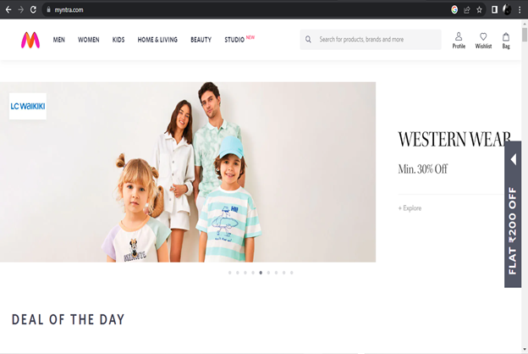

Project Name : Myntra - Online Shopping For Men, Women And Kids.

**Overview**

Myntra is Online Shopping Site for Fashion & Lifestyle in India. India’s Fashion Experts brings you a variety of footwear, Clothing, Accessories And Lifestyle products. It is a major Indian fashion e-commerce company headquartered in Bengaluru, Karnataka, India.

**History**

Established by Mukesh Bansal along with Ashutosh Lawania and Vineet Saxena.Myntra sold on-demand personalized gift items.It mainly operated on B2B(business-to-business)model during its initial years.

**Events Occurs-**

1. Between 2007 and 2010,the site allowed customers to personalize products such as T-shirts,mugs,mouse pads, and others.

2. In 2011, Myntra began selling fashion and lifestyle products and moved away from personalization. By 2012 Myntra offered products from 350 Indian and International brands. The website launched the brands Fastrack Watches and Being Human.

3. In 2014, Myntra was acquired by Flipkart.

4. On 10 May 2015, Myntra announced that it would shut down its website, and serve customers exclusively through its mobile app beginning 15 May.

5. In September 2017, Myntra negotiated the rights to manage Esprit Holdings's 15 offline stores in India.

**Goals**

1. Login Page

Username/email-id and password, login button

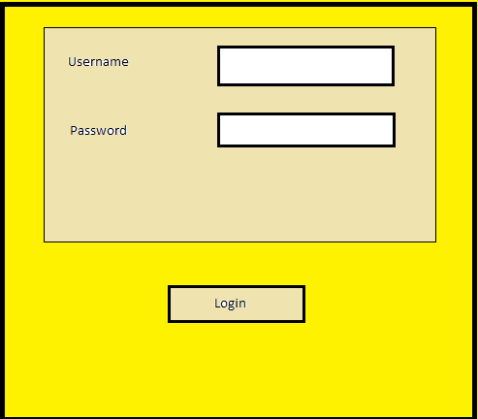

2. Home Page

Logo, Links to pages(men,women,children,home&living,beauty), profile,

wishlist, catagories to products, brands, offers

Filters:

Search bar, items in cart

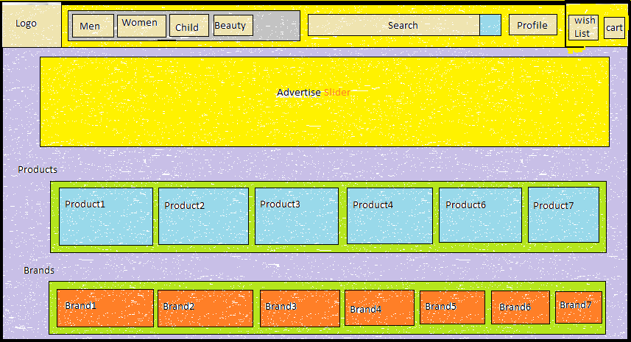

3. Profile Page

Personal detail, orders, wishlist, logout

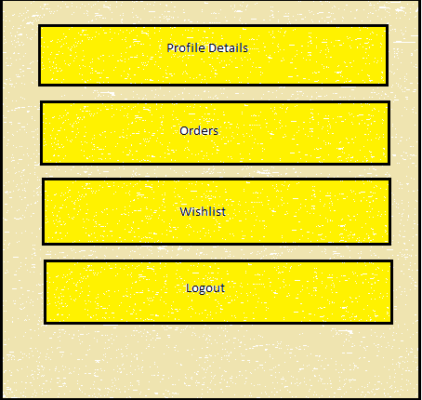

4. Product Page

Showing products detail, image, add the item, buy now

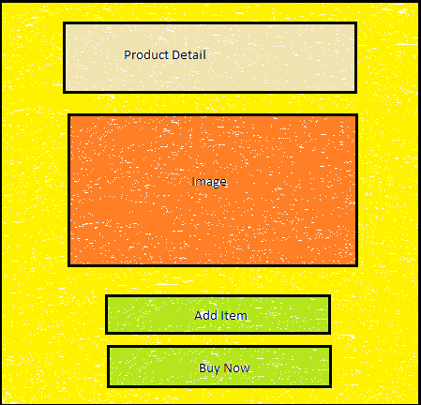

5. Address Page

Showing Address, delivery estimates, Price detail, continue

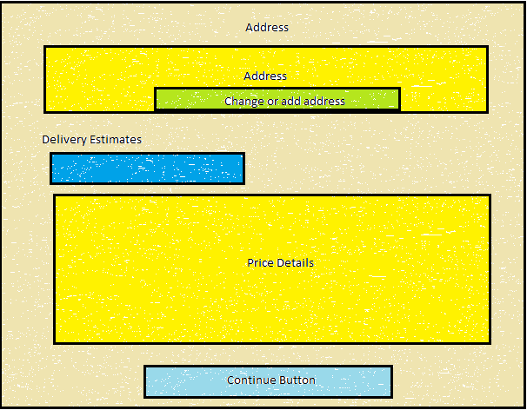

6. Payment Page

Buying options:

Cod/emi/one time online payment, google pay, upi

Payment Gateway

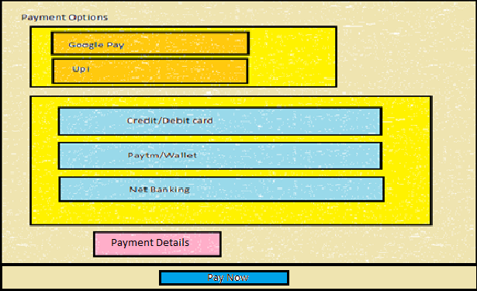

**Technology used in Myntra**

Front-End:

1. Html
2. Css
3. Bootstrap
4. React

Dynamic:

1. Javascript
2. AWS

Database:

1. Mongodb
2. Json Data

Code compilers:

1. Visual studio code
2. Git bash
3. Git hub
4. Node js

**Github Link: https://github.com/sujatapatil21196/Myntraclonewebsite**